|  |  |
| --- | --- |
| Team ID | PNT2022TMID13904 |
| Project Name | CONTAINMENT ZONE ALERTING |

# SETUP MOBILE APPLICATION ENVIRONMENT

**GEOFENCE IN ANDROID APP**

Geofence is a feature of Google Play Services. It is used to detect the user’s entry into or exit from a geographic region. It is typically used to detect the user’s entry into or exit from a geographic region. There are two types of geofences: circular and polygonal. Circular geofences are deﬁned by a center point and a radius. They are the simplest to deﬁne and are the most commonly used type of geofence. Polygonal geofences are deﬁned by a set of vertices that form the corners of the polygon. They are more complex to deﬁne but can be used to deﬁne more complex shapes such as irregularly shaped areas. To create a geofence, you need to specify the following parameters: The geographic location of the geofence. This can be speciﬁed as a latitude and longitude or as a place name. The radius of the geofence. This is the distance from the center of the geofence to the edge of the geofence. The type of geofence. This can be either a circular or a polygonal geofence.

Android Geofencing is a location based technology that is used to trigger a pre-deﬁned action when a mobile device enters or exits a geographic area, or “geofence.” Geofences can be created for any location, such as a restaurant, store, or park. What is the use of

Geofence in Android studio? Android geofencing with the Google Location Services API is a powerful way to improve the user experience of an Android app. This API allows ﬁne-grained control over geofences, giving developers the ability to monitor for changes to the user’s location with a high degree of accuracy and responsiveness. Is geofencing accurate? Geofences are accurate to

about 10 meters. That’s not bad for most applications, but if you need pinpoint accuracy, you’ll need to rely on GPS tracking. What is Geofencing in marketing? Geofencing is a location-based marketing technique that uses GPS or RFID technology to create a virtual geographic boundary or “geofence” around a place or area.

Geofencing is a feature in a smartphone or mobile device that uses GPS or RFID technology to trigger a pre-programmed action when the user enters or exits a virtual boundary set up around a geographic location. Geofencing allows you to set up a virtual perimeter around a real-world location. When someone enters or leaves that area, you can trigger an event. Geofencing is commonly used to trigger an

action on a mobile device, such as sending a push notiﬁcation or opening a speciﬁc app. Geofencing can be used for a variety of purposes, such as: - To track the location of a person or object - To trigger an action on a mobile device when the user enters or leaves a speciﬁc location - To create a virtual perimeter around a real-world location

Geofencing is a location-based service, that sends a notiﬁcation to the user when he enters or exits the area. Geofencing combines awareness of the user's current location with awareness of nearby landmarks, such as landmarks, cities, parks, and transit stations. To get the user's current location, we use the FusedLocationProviderClient. It is a location API that combines all the location providers such as GPS, Network, and WiFi to provide the user's current location.

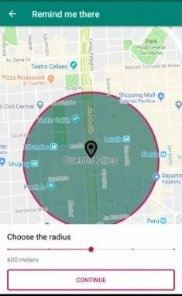

# How to set up a geofence?

To set up a geofence, we need to create a Geofence object using the Geofence.Builder class. This class requires the following parameters:

* The geofence's circular region
* The geofence's expiration duration
* The geofence's transition types
* The geofence's notiﬁcation responses

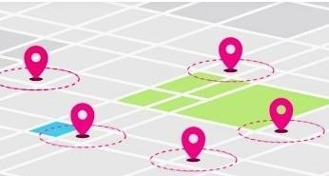

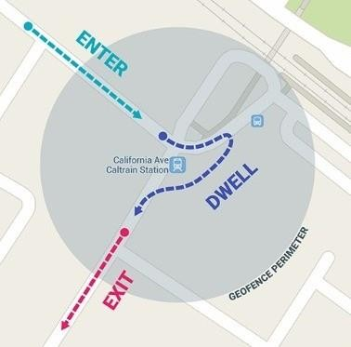

# How to get the user's current location?

To get the user's current location, we use the FusedLocationProviderClient. It is a location API that combines all the location providers such as GPS, Network, and WiFi to provide the user's current location.